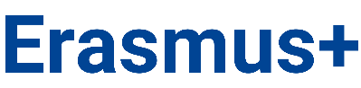

Riga 1st Medical College of the University of Latvia
TEACHING STAFF/PERSONNEL
APPLICATION FOR EXCHANGE PROGRAMME
1. Personal data
Name _______________ Surname____________________
Telephone number____________ E-mail_______________
2. Information about employment
Position:
Department:

3. Have you previously participated in the Erasmus programme? | If yes, please specify in which activity (teaching, staff training/job shadowing)
- yes
- no
4. Selected foreign companies/institutions in order of priority:

Priority | Name of the company/institution and country | Objective
1.
2.
3.
7. Please briefly describe why you would like to participate in the exchange programme

By my signature, I confirm that I agree to the processing of my personal data provided by me, carried out by LU Riga 1st Medical College, in order to ensure the implementation of the Erasmus+ mobility programme. I am informed that I can review the personal data processing terms here: https://www.rmk1.lv/wp-content/uploads/2026/04/LU-Rigas-1.-medicinas-koledza_Privatuma-politika.pdf
Signature Signature clarification Date
9. Signature of the Chair of the Selection Committee confirming support for participation in the exchange programme
Chair of the Selection Committee:
Signature Signature clarification Date

